DO NOT DRINK ORDER

DO NOT DRINK THE WATER
UNTIL FURTHER NOTICE

[NAME] _______________water system, PWS ID#NV000 _______has experienced a situation that could result in contamination of your drinking water.

What should I do?
Bottled water should be used for drinking, making ice, brushing teeth, washing dishes, and food preparation until further notice. Questions regarding consumption by pets should be directed to your veterinarian. Water may be used for laundry purposes, swamp coolers and bathing depending on the situation.

What has happened?

What is being done? [Describe situation and corrective actions taken.]

We will inform you when tests show no contamination and the DO NOT DRINK ORDER has been rescinded. We anticipate resolving the problem within [estimated time frame] ____________.
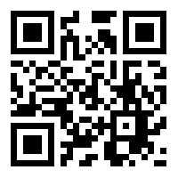
For more information please contact (Water System name :)
_________________________ at (phone :) _________________________.

*Please share this information with all the other people who drink this water, especially those who may not have received this notice directly (for example, people in apartments, nursing homes, schools, and businesses). You can do this by posting this notice in a public place or distributing copies by hand or mail.*

This notice is being sent to you by [system]. State Water System ID#: ___________.

